**Top 15+Arduino Projects For Beginners with Free Source Code**

[[JOKEN VILLANUEVA](https://medium.com/@pies052022?source=post_page-----a60cf8a3b047--------------------------------)](https://medium.com/@pies052022?source=post_page-----a60cf8a3b047--------------------------------)

[JOKEN VILLANUEVA](https://medium.com/@pies052022?source=post_page-----a60cf8a3b047--------------------------------)

·

[Follow](https://medium.com/m/signin?actionUrl=https%3A%2F%2Fmedium.com%2F_%2Fsubscribe%2Fuser%2F5b98163f575c&operation=register&redirect=https%3A%2F%2Fmedium.com%2F%40pies052022%2Ftop-15-arduino-projects-for-beginners-with-free-source-code-a60cf8a3b047&user=JOKEN+VILLANUEVA&userId=5b98163f575c&source=post_page-5b98163f575c----a60cf8a3b047---------------------post_header-----------)

6 min read

·

Dec 18, 2023

67

Are you looking for ***Arduino Projects and ideas for beginners***?

Or are you a person who uses Arduino in their professional work and is looking for some inspiration for your next Arduino project?

Well, you have come to the right place!

I will show you the most useful**Arduino projects** for beginners.

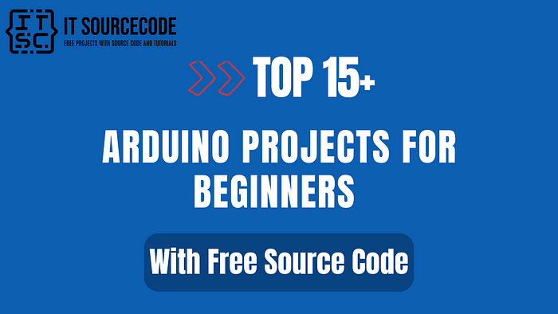

**Top 25 Arduino Projects For Beginners with Free Source Code**

Most of the projects that I will show you will only use affordable sensors present online.

They are easy to acquire and will not cost you a great fortune.

**1.**[**Arduino Remote Control Light Switch**](https://itsourcecode.com/free-projects/arduino-projects/arduino-remote-control-light-switch-code-and-wiring-diagram/)

This Arduino project for beginners can turn on a light using an infrared sensor.

You can just point and push the button to turn on the light.

The project uses a relay module and IR receiver to turn on the lamp. How awesome is that?

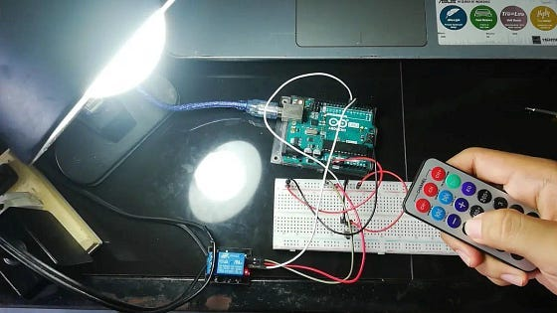

**2.**[**Infrared Remote Control in Arduino**](https://itsourcecode.com/free-projects/arduino-projects/infrared-remote-control-in-arduino-code-and-wiring-diagram/)

Infrared (IR) remote controls in Arduino are handheld devices that can control other devices using infrared light.

IR remote controls need a line of sight to operate.

This means someone needs to point the IR to the receiver for the signal to be decoded.

Using RGB values, you can recreate any color you want and assign them to each button.

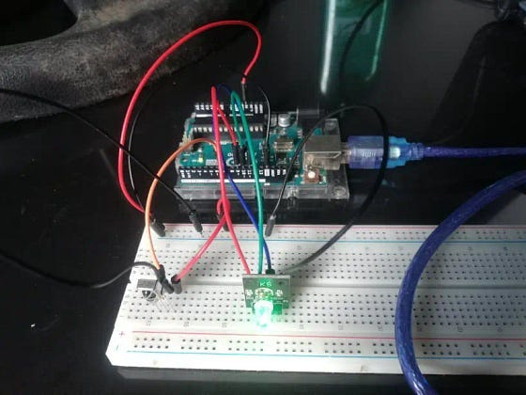

**3.**[**DS1302 Real Time Clock**](https://itsourcecode.com/free-projects/arduino-projects/ds1302-real-time-clock-module-code-and-wiring-diagram/)

You will learn how to use a DS1302 real-time clock module in Arduino.

Real-Time Clock modules are used in many devices like computers, televisions, and many others.

These modules have their batteries as a secondary power source to keep the time updated.

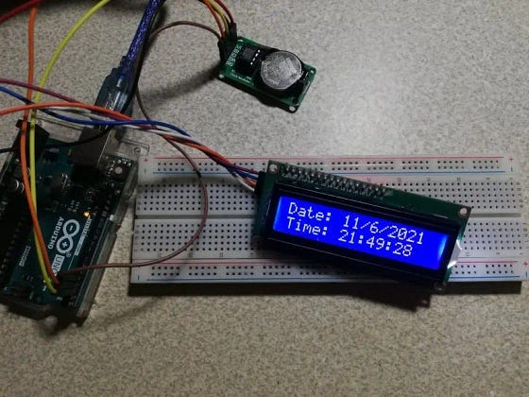

**4.**[**Arduino Water Level Sensor with Python Live Data Plotting**](https://itsourcecode.com/free-projects/arduino-projects/arduino-water-level-sensor-with-python-live-data-plotting/)

Creating this project will let you do serial communication from Arduino to Python.

This is very useful if you are gathering data live or constantly monitoring liquids.

Sensing the water level using Arduino can be done using different modules and sensors.

For this project, a water level sensor is used paired with Python!

The Arduino will provide the data while the Python program will create a graph and plot the data in real time.

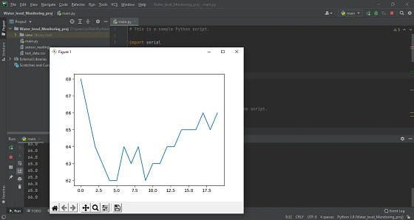

**5.**[**Arduino Temperature Alarm**](https://itsourcecode.com/free-projects/arduino-projects/arduino-temperature-alarm-code-and-wiring-diagram/)

This project will let you identify the room temperature.

After that, it will sound an alarm if it gets too hot.

This is very useful if you monitor room temperatures and can be combined with other Arduino projects.

This simple Arduino project will let you identify the room temperature.

After that, it will sound an alarm if it gets too hot.

This is very useful if you monitor room temperatures and can be combined with other Arduino projects.

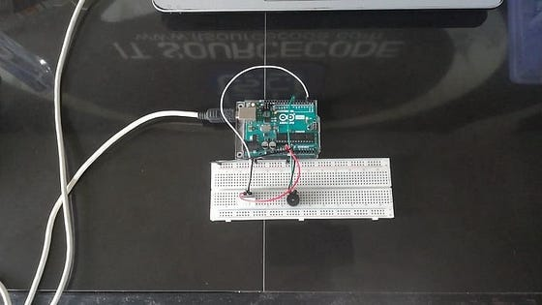

**6.**[**Connecting a Potentiometer to Arduino**](https://itsourcecode.com/free-projects/arduino-projects/connecting-a-potentiometer-to-arduino-code-and-wiring-diagram/)

A potentiometer is simply a varying resistor.

This means you can amplify or reduce the amount of electricity passing through the circuit.

This is another mode of input and can be used in different projects.

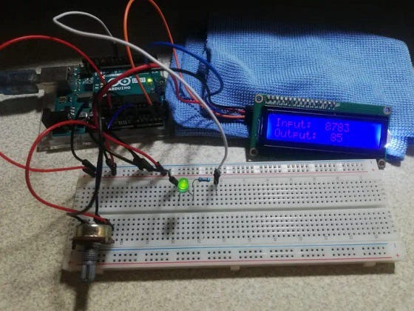

**7.**[**Temperature Monitoring System Using Arduino and Python Live Data Plotting**](https://itsourcecode.com/free-projects/arduino-projects/temperature-monitoring-system-using-arduino-and-python-live-data-plotting/)

Python and Arduino are a deadly combo! in this cool Arduino project, a DHT22 sensor module detects the temperature and humidity while the Python script saves the data and plots it on a graph.

A great start in Machine Learning!

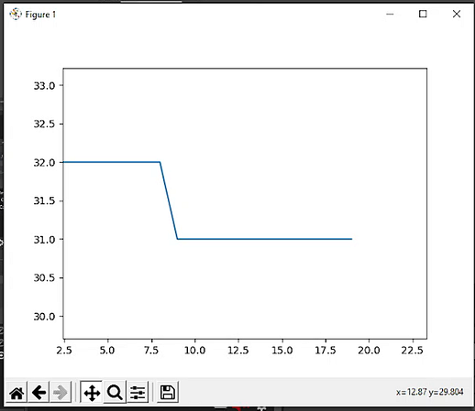

**8.**[**RFID Door Lock with Python**](https://itsourcecode.com/free-projects/arduino-projects/rfid-door-lock-arduino-project-with-data-logging-in-python/)

One project that you should consider is the RFID Door Lock with Python. This device uses RFID to unlock a room.

A bonus is this project uses Python to log the activities. Awesome, right?

RFID Door Lock Using Arduino Project are common security measures for granting access to persons in authority.

But without any means of security log, you cannot trace the persons who accessed a secured area.

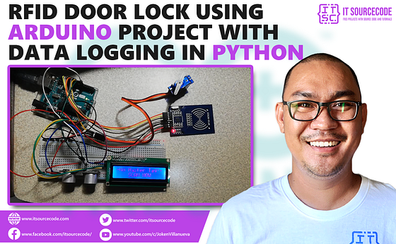

**9.**[**Relay Module Connection in Arduino: Code and Wiring Diagram**](https://itsourcecode.com/free-projects/arduino-projects/relay-module-connection-in-arduino-code-and-wiring-diagram/)

Another simple Arduino project is a relay module connection.

As simple as it seems, it is an important module to have, especially in using high-voltage electricity.

This is a must-have in IoT projects.

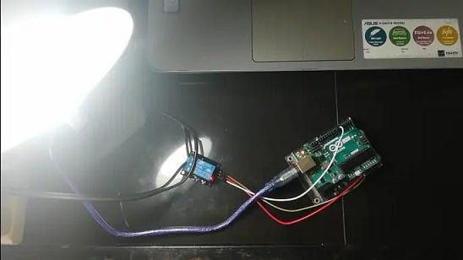

**10.**[**Controlling a Servo with Joystick in Arduino: Code and Wiring Diagram**](https://itsourcecode.com/free-projects/arduino-projects/controlling-a-servo-with-joystick-in-arduino-code-and-wiring-diagram/)

Controlling a servo with a joystick is simple.

For this project, the servo will move according to the movement of the joystick.

Since the servo only moves horizontally, you only need to code the x-axis.

This simple joystick-controlled servo has a lot of potential! Using a 2-axis joystick, you can move the head of the servo.

This has a lot of uses, especially in robotics.

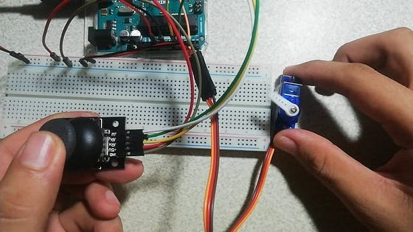

**11.**[**5V Stepper Motor Arduino Interfacing**](https://itsourcecode.com/free-projects/arduino-projects/5v-stepper-motor-arduino-interfacing-code-and-wiring-diagram/)

Stepper motors are a kind of DC motor that moves in small steps.

With very precise motion, stepper motors are the best choice for projects that require precise and accurate movement.

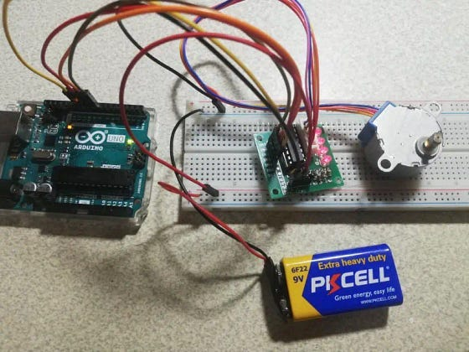

**12.**[**Arduino Keypad and LCD**](https://itsourcecode.com/free-projects/arduino-projects/arduino-keypad-and-lcd-code-and-wire-diagram/)

Keypads on devices are essential mode of input.

Without it, users cannot input numbers to a device or choose and select a function.

It is a burden if there are no keypads present.

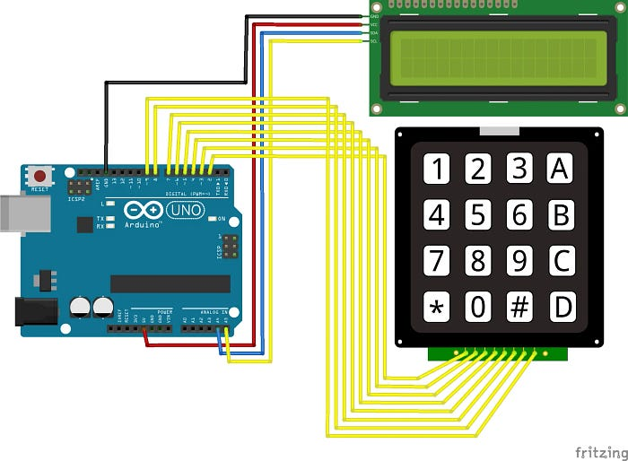

**13.**[**2-Axis Joystick Interfacing in Arduino**](https://itsourcecode.com/free-projects/arduino-projects/2-axis-joystick-interfacing-in-arduino-code-and-wiring-diagram/)

This is similar to a PlayStation 2 analog joystick.

You can use this in controlling motors, servos, or use it as an input device.

You will be using Arduino Uno for this project. It is an easy to use microprocessor board.

Arduino Uno is suitable for any projects and is the cheapest and widely used microprocessor board in the Arduino family.

This is great for all kinds of IoT projects.

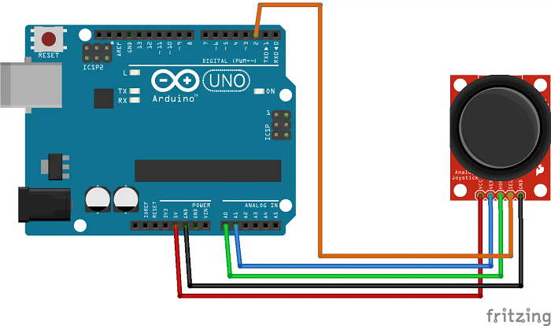

**14.**[**Sound Sensor Module**](https://itsourcecode.com/free-projects/arduino-projects/sound-sensor-module-interfacing-in-arduino-code-and-wiring-diagram/)

Using this module, you can capture sound as input to control other parts of your device.

Integrating this into your projects can greatly improve the functionality of your device.

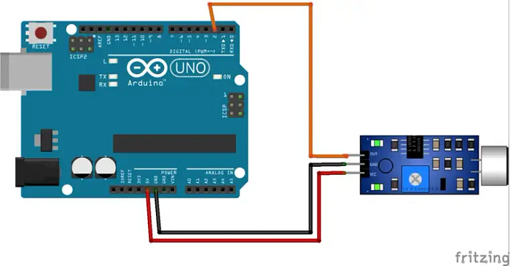

**15.**[**Ultrasonic Sensor in Arduino**](https://itsourcecode.com/free-projects/arduino-projects/ultrasonic-sensor-in-arduino-code-and-wiring-diagram/)

This sensor measure distances using sound waves bouncing back to itself. Many projects and devices use this type of sensor.

Using an ultrasonic sensor is cheap and easy. You can buy it online for a very cheap price. Also, an updated library makes it easier to code.

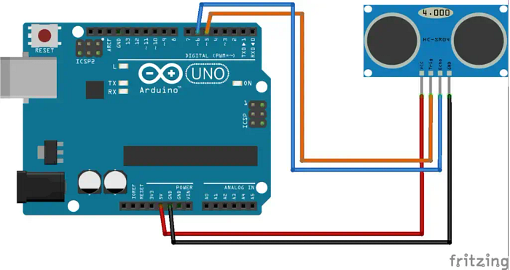

**16.**[**Controlling Arduino Using Python PyFirmata**](https://itsourcecode.com/free-projects/arduino-projects/controlling-arduino-using-python-pyfirmata/)

Pyfirmata is a Python package that lets you FULLY CONTROL the Arduino and code through Python.

Pyfirmata is a Python package that lets you communicate your Python script to your Arduino.

This gives you access to all functions of the pins without coding the Arduino. Simply put, you can connect sensors without coding the board.

**Conclusion**

So, there you have it. You now have an idea about**Arduino projects**, especially for beginners.

These projects might seem hard at first, but they’re actually pretty easy once you understand them.

You can combine them with other Python or Arduino projects to create a cool system!

I hope these resources assist you in creating your own project using the different programming languages mentioned above.

If you found this article valuable, please leave a comment below and share your thoughts about this article.

[**Itsourcecode.com**](https://itsourcecode.com/)**🚀**

Thank you for being a part of the Itsourcecode community!

Before you leave, please consider the following:

I would appreciate it if you could show your support by clapping and following the author

Follow us on [[**Facebook**](https://www.facebook.com/itsourcecode)]  
Visit our other platform: [[**SourceCodeHero**](https://sourcecodehero.com/)**]**.